1. **Agenda**:
   1. Graphical user interface, text

      Description automatically generated
2. 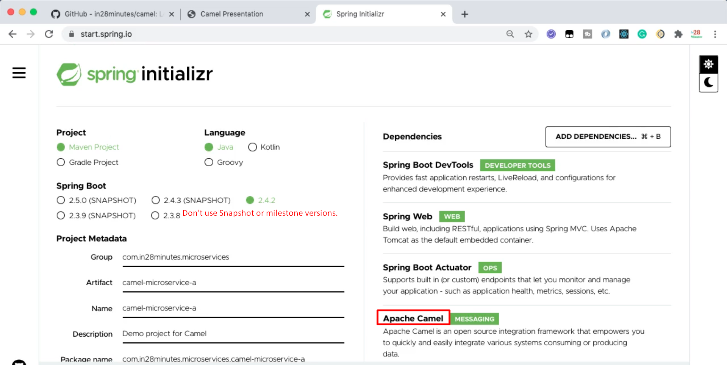
3. Graphical user interface, text, application, email

   Description automatically generated
4. Load both the projects in Eclipse.
5. Mentor is using Eclipse Enterprise IDE.
6.  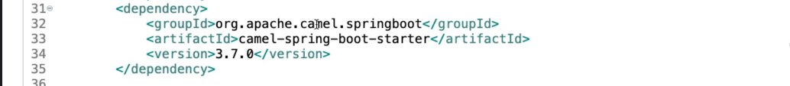
7. We just setup the microservices which we will use in next few steps.